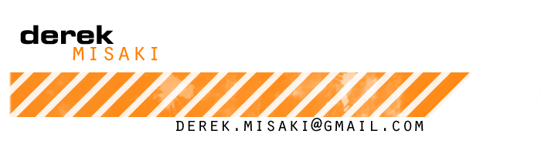
www.misaki3d.com
503-309-7770
Kenmore, WA

Technical Skills

- Autodesk Maya
  - Modeling, texturing, rigging, MEL scripting.
- Autodesk 3ds Max
  - Modeling, texturing, rigging.

- PBR Texture/Material Pipelines
- Pixologic Zbrush
- Adobe Photoshop
- Substance Painter
- Unreal Engine 3, 4, Unity
- Other Proprietary Engines

Experience

- Aug 2018-Present Lakshya Digital/Keywords Studios Redmond, WA
Outsource Artist
  - Asset task setup, pre-production, polish, and integration of outsourced assets into multiple studio pipelines across different titles.
  - Maintaining good communication between client and outsource teams.
  - Evaluation and critique of incoming outsourced assets.

- April 2015-April 2018 Turn 10 Studios/Microsoft Redmond, WA
Car Artist
  - Polish on car assets in game including remodeling, retexturing, animation setup, and shader/material setups.
  - Communication with multiple teams for asset specifications and licensing requirements.
  - Engine integration setup of outsourced assets.
  - QA test passes on newly submitted outsourced assets.

- Sept 2012-April 2014 Zombie Studios Seattle, WA
Environment Artist
  - Creation, rigging, and implementation of new environment, weapon, and vehicle assets from concept.
  - Unreal engine 3, 4, and Unity integration, shader work, and world placement.
  - Updating of assets for current and next generation fidelity.

- Nov 2010-July 2012 Monolith Productions/WB Games Kirkland, WA
Associate Character Artist
  - Evaluation, cleanup, rigging, and weighting of outsourced character and weapon assets.
  - Assisting lines of communication between the art team and outsourcers.
  - Modification of assets for uniformity and functionality.
  - Creation and implementation of new character art assets from concept.
  - Memory management and pipeline cleanup.

- Apr 2009-Present 3D Freelance Artist Kenmore, WA
3D Modeler & Texture Artist
  - Contracted to model components of Columbia Sportswear shoes.
  - Contracted to model and texture numerous random objects for Doppstadt.
  - Rigging and weight painting for characters and objects for multiple clients.

Education

- 2006-2010 The Art Institute of Portland Portland, OR
  - Bachelor of Fine Arts, Game Art & Design.
  - Concentration: Technical Direction/Rigging and 3D Modeling.

